3/18/2024

Michael Marinovic

SPS CUNY

IS 362 Week 9

Project 3

1. For your database, you should download and install the appropriate version of the Chinook database for your RDBMS, which is available here, under the downloads tab: https://chinookdatabase.codeplex.com/

Chinook Database: [lerocha/chinook-database: Sample database for SQL Server, Oracle, MySQL, PostgreSQL, SQLite, DB2 (github.com)](https://github.com/lerocha/chinook-database)

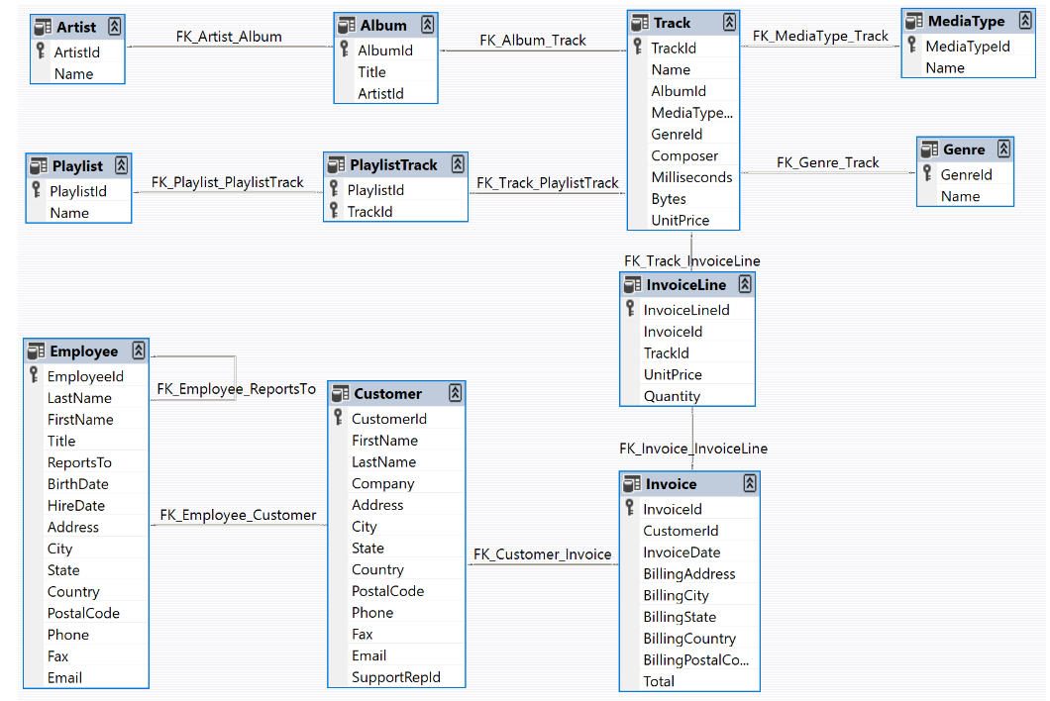

This can be tested in all supported databases. For this Project it will be done in SQLite3. Retrieved from: <https://www.sqlite.org/index.html>

Upload the Chinooks database into SQLite3. This is even easier with SQLite Studio.

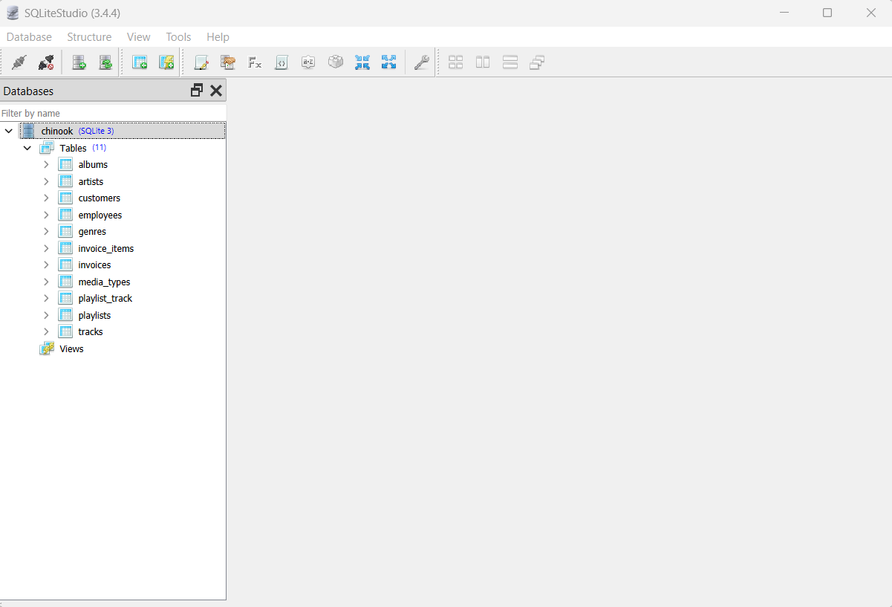

1. Your task is to create a pandas DataFrame that displays Customers’ Last Name and First Name, and each customer’s purchased Track names and Album Titles. The information should be sorted by Customer LastName then Customer FirstName.

SELECT LastName, FirstName, Name, Title FROM customers

INNER JOIN invoices ON Invoices.CustomerId= customers.CustomerId

INNER JOIN invoice_items ON invoices.InvoiceId= invoice_items.InvoiceId

INNER JOIN tracks ON tracks.TrackId = invoice_items.TrackId

INNER JOIN albums ON albums.AlbumId =tracks.AlbumId

ORDER BY LastName, FirstName

In SQLiteStudio this appears as the following from the Chinook database Github file.

